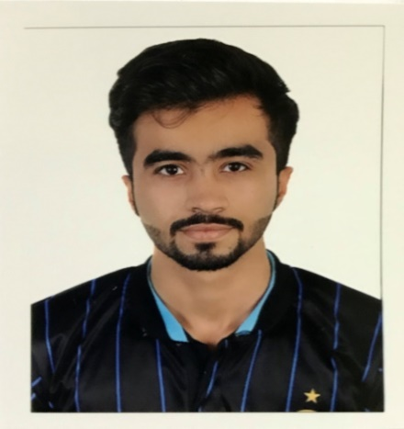

***Bahrain University***

*Graduate of the Faculty of Physical Education at the University of Bahrain rate 2.61 GPA*

*2014*

*2019*

*Hamad Town,Bahrain*

*37155137*

*a.20010@hotmail.com*

*23 years old*

* ***EDUCATION***

*2011*

*2014*

*2014*

*2015*

*2014*

*2015*

***Hamad town secondary school***

*Secondary secondary rate 83%*

***English courses Dar Almaarifa Institute***

*Study the basics of English language*

***English courses Modern Institute***

*Study the basics of English language*

Good in Communication Skills

*ARABE*

*ENGLISH*

*ENGLISH*

***S.Ahmed S.Jalal***

*WORD*

*EXCEL*

*POWERPOINT*

*CINÉMA*

*GAMES*

*Sport (football)*

* ***HOBBIES***
* ***SKILLS***
* ***LANGUES***